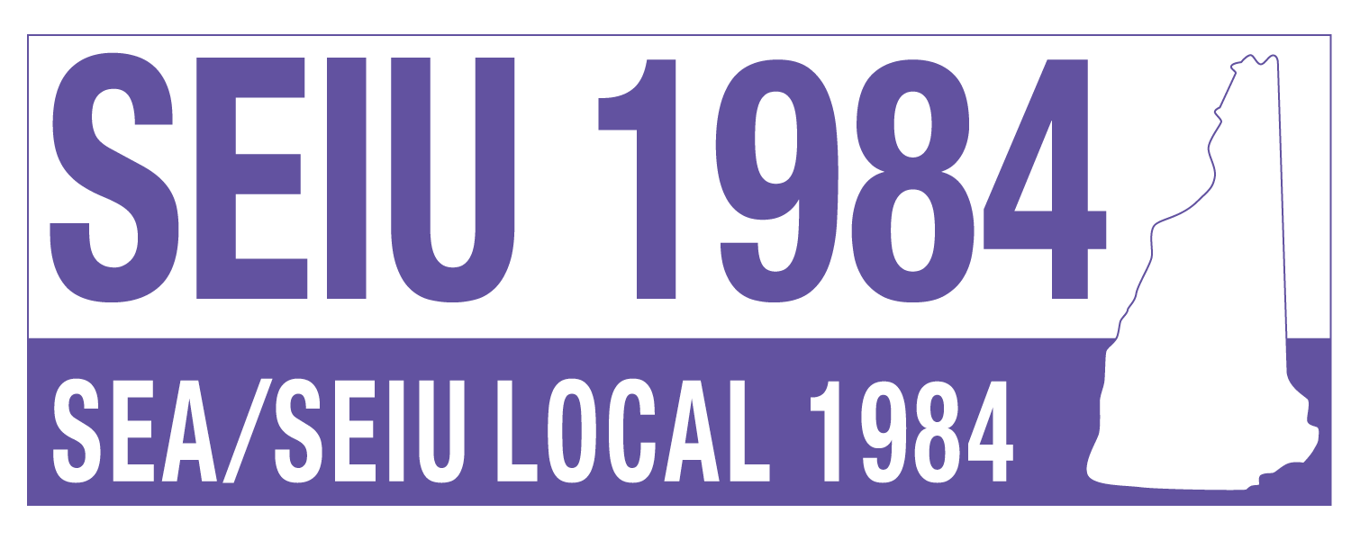

2026 CANDIDATE QUESTIONNAIRE

We, the members of the State Employees’ Association (SEA), are dedicated stakeholders and taxpayers of New Hampshire. Our goals are to improve the working conditions and well-being of all NH citizens, leaving no one behind. Protect and promote our members’ right to live and retire with dignity. Negotiate robust worker-friendly contracts that empower our members to thrive. Grow our membership to strengthen our collective power at worksites, in elections, and at the Legislature.
The SEA, SEIU Local 1984, will endorse candidates who demonstrate strong values and support for our Six Tenets. These tenets form the foundation of a safe, healthy, and productive workforce and a just society.
Six Tenets for Endorsement:
- Union Building: Support legislation and policies that allow workers to organize and collectively bargain for better wages, benefits, and working conditions.
- Retirement: Preserve the safety and security of our retirement systems.
- Fair Wages: Ensure all workers receive fair wages for their work.
- Work Conditions: Strengthen worker safety and improve working environments.
- Healthcare: Provide quality, affordable healthcare to all workers and retirees.
- Environment: Foster safe and healthy living and working conditions.
Thank you for participating in SEA/SEIU 1984’s State Questionnaire. We look forward to working with you throughout the endorsement process and beyond.
For questions, please contact Bob Blaisdell at bblaisdell@seiu1984.org
Candidate Information
- Name:
- Office Sought:
- Primary Contact Person Name, Phone Number & Email:
2024 Campaign Profile
- Campaign Staff:
  - Campaign Manager:
  - Finance Director:
  - SEA/SEIU 1984 Liaison:
- Other Information:
  - Party Affiliation: Democratic ___ Republican ___ Other ___
  - Are you a Union member? Yes/No
  - Are you an incumbent or a new candidate for the office you seek?
  - Top Three Issues: ________________ ________________ ________________

Narrative Questions
When completing narrative questions, please be specific in your details and provide appropriate evidence so our Committee members can make informed decisions about your candidacy.
Union Building:
- Will you support changes to labor law that allow workers to organize across industries and make it easier for workers to organize? Yes/No
- If elected, will you support efforts to create good jobs for citizens by ensuring that investments—including contracts, grants, loans, loan guarantees, tax breaks, and other forms—support positions that provide fair wages, paid leave, and decent benefits? Yes/No
Describe past actions or future intentions:

Retirement:
- Will you protect our current defined retirement benefits and oppose any legislation that undermines state, local, and private-sector pensions? Yes/No
- If elected, will you support retirement plan proposals for citizens who don’t currently have retirement plans at work? Yes/No
Describe past actions or future intentions:
Open text box, paragraph format.

Fair Wages:
- Will you stand with workers seeking higher wages and union rights? Yes/No
- If elected, would you support moving the state minimum wage to a living wage and phasing out subminimum wages for tipped workers and workers with disabilities? Yes/No
Describe past actions or future intentions:
Open text box, paragraph format.

Work Conditions:
- Will you support proposals for improving working conditions for New Hampshire state employees? Yes/No
- If elected, will you support work-from-home policies for local and state employees? Yes/No
- If elected, will you support New Hampshire adopting Occupational Safety and Health Administration safety protections? Yes/No

Describe past actions or future intentions:
Open text box, paragraph format.

Healthcare:
- Explain your vision for attaining affordable healthcare coverage in New Hampshire.
Open text box, paragraph format.

- If elected, will you support immediate changes to strengthen our healthcare system, either as an end in themselves or as we transition to a new universal coverage system (i.e., regardless of your position on universal coverage proposals)? Yes/No
- If elected, will you support legislation and take other actions to ensure the stability of hospital financing and enable hospitals and other providers to fully serve their communities, including measures to prevent cuts to Disproportionate Share Hospital payments, increased funding for Graduate Medical Education, and reversal of ”site-neutral” payment policies that harm hospital budget? Yes/No
Describe past actions or future intentions:
Open text box, paragraph format.

Environment:
- Would you support legislation providing affordable and workforce housing for families and workers? Yes/No
- If elected, will you support initiatives to grow the production of U.S. clean energy through policies and investments in renewable energy, greater energy efficiency, clean energy manufacturing, and infrastructure upgrades, and in the process, create family-sustaining jobs? Yes/No
Describe past actions or future intentions:
Open text box, paragraph format.

We appreciate your detailed responses, as they help our Committee make informed decisions about your candidacy.

